

**MALLA REDDY UNIVERSITY CLOTHING**

# Designed and Developed by

|  |  |
| --- | --- |
| Maroju Sravani | 2111CS010562 |
| Panasa Shruthi | 2111CS010543 |
| VankamSriramSakethCharan | 2111CS010578 |
| Shubham Jitendra Pandit | 2111CS010544 |

**Guided by**

**Mrs.P.Sabitha**

**Department of Computer Science & Engineering MALLA REDDY UNIVERSITY, HYDERABAD**

**2022-2023**



**CERTIFICATE**

This is to certify that this is the Application development lab record entitled “**MALLA REDDY UNIVERSITY CLOTHING”**

, submitted by M.Sravani(2111CS010562)**,** P.Shruthi (2111CS010543) ,V.Sriram Saketh (2111CS010578) ,J.Shubham (2111CS010544) B. Tech **II** year **II** semester, Department of CSE during the year 2022-23. The results embodied in this report have not been submitted to any other university or institute for the award of any degree or diploma.

**Internal Guide HOD-CSE**

**Mrs.P.Sabitha Dr. Shaik Meeravali**

**External Examiner**



**DECLARATION**

I declare that this project report titled MALLA REDDY UNIVERSITY

CLOTHING submitted in partial fulfilment of the degree of B. Tech in CSE is a record of original work carried out by me under the supervision of Mrs.P.Sabitha, and has not formed the basis for the award of any other degree or diploma, in this or any other Institution or University. In keeping with the ethical practice in reporting scientific information, due acknowledgements have been made wherever the findings of others have been cited.

**Student Signature**

|  |  |
| --- | --- |
| M.Sravani | 2111CS010562 |
| P.Shruthi | 2111CS010543 |
| V.Sriram Saketh | 2111CS010578 |
| J. Shubham | 2111CS010544 |
|  |  |

**TABLE OF CONTENT**

|  |  |
| --- | --- |
| **DESCRIPTION** | **PAGE NUMBER** |
| **CERTIFICATE** | **2** |
| **DECLARATION** | **3** |
| **ACKOWLEDGEMENTS** | **4** |
| **ABSTRACT** | **6** |
|  |  |
|  |  |

|  |  |  |  |
| --- | --- | --- | --- |
| **Chapter 1 Introduction** | | **7** | |
| **1.1 Introduction** | |  | |
| **1.2 Problem Statement** | |  | |
| **1.3 Objective of Project** | |  | |
|  | |  | |
| **Chapter 2 Problem Identification** | | **9** | |
| **2.1 Proposed System** | |  | |
|  | |  | |
| **Chapter 3 Requirements** | | 11 | |
| **3.1 Software Requirements** | |  | |
| **3.2 Hardware Requirements** | |  | |
| **Chapter 4 Design and Implementation** | | **12** | |
| **4.1 Design** | |  | |
| **4.2 Implementation**  **4.3 Architecture** | |  | |
| **Chapter 5 Code** | | **15** | |
| **5.1 Source Code** | |  | |
| **5.2 Screenshot of Application** | |  | |
| **Chapter 6 Conclusion** | | **30** | |
| **6.1 Conclusion** | |  | |
|  | |  | |
| **REFERENCES** | |  | |
| **Appendix 1 Title of the appendix 1** | |  | |
| **Appendix 2 Title of the appendix 2** | |  | |

**ABSTRACT**

There are many universities that have clothing websites associated with them, often known as campus stores or bookstores. These stores typically sell clothing and accessories that feature the university’s name, logo, or colors, and may also sell textbooks, supplies, and other items.

Having a campus store or clothing website is a common way for universities to promote school spirit and generate revenue. These stores often feature a wide variety of merchandise, including t-shirts, sweatshirts, hats, and other accessories, and may offer online ordering and shipping options for customers.

Some universities may also collaborate with well-known clothing brands or designers to create exclusive clothing lines that feature the university’s branding. These collaborations can help to further promote the university and create unique and fashionable items for students and alumni.

Overall, having a clothing website associated with a university can be a great way to showcase school spirit and generate revenue, while also providing students, alumni, and fans with a way to show their support for their favorite University.

**CHAPTER – 1**

**INTRODUCTION**

* 1. **Introduction**

The Malla Reddy University Clothing website, the perfect destination for comfortable high-quality apparel that showcases your school spirit .Our clothing collection includes a wide range of t-shirts, hoodies , sweatshirts, and other items, all featuring the MRU University logo and designs. By purchasing clothing from our website, you are not only showing your school pride, but you are also supporting the university and contributing to various programs and scholarships that benefit students. Our website is user-friendly and easy to navigate, offering a seamless shopping experience for our customers.

* 1. **Problem Statement**

Malla reddy University's Clothing line faces significant challenges as it fails to meet the expectations and preferences of the student community. The current collection suffers from outdated designs, limited size options, poor quality materials, and a lack of variety. This has resulted in student dissatisfaction, lack of enthusiasm in promoting university spirit, and a weakened sense of identity. Moreover, the unattractive clothing line hampers brand recognition and revenue generation opportunities. It is crucial for Mallareddy University to address these issues promptly and revamp its clothing line to enhance student satisfaction, foster a stronger sense of pride and belonging, and establish a profitable and recognizable brand presence.

* 1. **Objective**

objective of Mallareddy University's Clothing line is to create a vibrant and appealing collection that aligns with the preferences and aspirations of the student community. The main goals include:

1. Enhancing Student Satisfaction: The clothing line aims to address the students' expectations by offering stylish and comfortable garments that reflect current fashion trends. By doing so, it aims to increase student satisfaction and promote a sense of pride and identity among the students.

2. Fostering School Spirit and Unity: The clothing line seeks to strengthen the sense of belonging and community among the students. It aims to create a shared identity and promote school spirit by designing clothing that represents the university's values, traditions, and achievements.

3. Improving Brand Recognition: By developing an attractive and well-received clothing line, Mallareddy University aims to enhance its brand recognition both within and outside the campus. The clothing will act as a promotional tool, increasing awareness of the university and its programs among potential students, alumni, and the wider community.

4. Generating Revenue: The objective is to create a profitable merchandise line that attracts students, alumni, and supporters of Mallareddy University. By offering desirable clothing options, the university aims to increase sales and generate additional revenue to support various student initiatives and academic programs.

5. Promoting Student Engagement: The clothing line aims to encourage student involvement and engagement by creating opportunities for students to actively promote and represent their university through clothing. It seeks to foster a sense of ownership and pride among the students, encouraging them to participate in events, activities, and sports

**CHAPTER – 2**

**PROBLEM IDENTIFICATION**

**2.1 Proposed System**

Enhanced Visual Appeal:

* The proposed website will have an updated and visually appealing design.
* The use of modern and attractive UI elements, color schemes, and typography will enhance the overall look and feel.
* Visual elements such as high-quality product images and engaging banners will captivate users' attention.

Improved User Navigation:

* The website will have a clear and intuitive navigation structure.

Users will be able to easily find products, navigate different categories, and access important pages.

* A user-friendly menu and search functionality will assist users in quickly finding what they are looking for.

Responsive Design:

* The website will be fully responsive, providing an optimal viewing experience across various devices, including desktops, tablets, and mobile phones.
* Responsive design will ensure that the website layout and content adapt seamlessly to different screen sizes, improving usability and accessibility.

Secure and Reliable:

* The proposed system will prioritize security measures to protect user data and ensure secure transactions.
* Secure socket layer (SSL) encryption will be implemented to encrypt sensitive user information during transmission.
* Regular security audits and updates will be performed to mitigate any potential vulnerabilities.

Scalability and Performance:

The website will be designed to handle a large number of concurrent users and high traffic volumes.

Server configurations will be implemented to ensure optimal performance and fast page loading times.

The proposed system aims to enhance the user experience, improve website performance, and provide a secure and seamless shopping experience for your customers. By implementing these features and functionalities, you can attract more customers, increase customer satisfaction, and drive revenue growth for your business.

**CHAPTER – 3**

**REQUIREMENTS**

* 1. **Software Requirements**
* Frontend: HTML,CSS, JAVASCRIPT,Angular,Bootstrap
* Backend: Node.js,MySql

**3.2 Hardware requirements**

* Processor: Intel Core i5 or equivalent, 2.5 GHz or higher
* RAM: 8 GB or higher
* Storage: Minimum 100 GB of free disk space
* Display: 1366x768 resolution or higher
* Graphics Card: Integrated or dedicated graphics card with at least 1 GB VRAM
* Network: Ethernet or Wi-Fi connectivity for web access
* Input Devices: Keyboard and mouse or compatible pointing device
* Operating System: Windows 10, macOS, or Linux
* Web Browser: Google Chrome, Mozilla Firefox, or Safari for web interface access
* Internet Connection: High-speed internet connection for data retrieval and updates

**CHAPTER – 4**

**DESIGN AND IMPLEMENTATION**

**4.1 Data Flow**

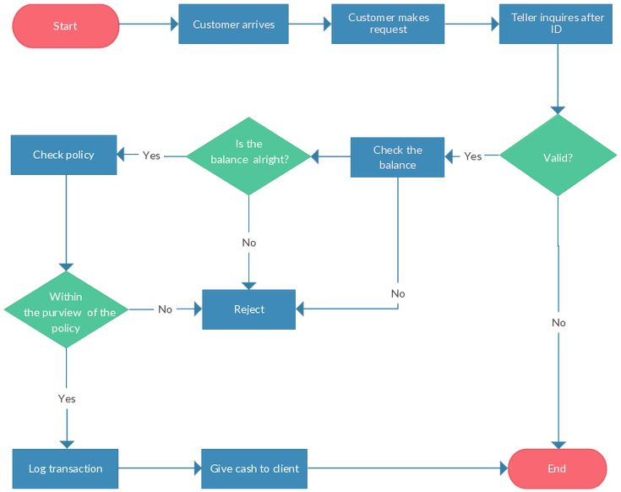

**4.2 Implementation**

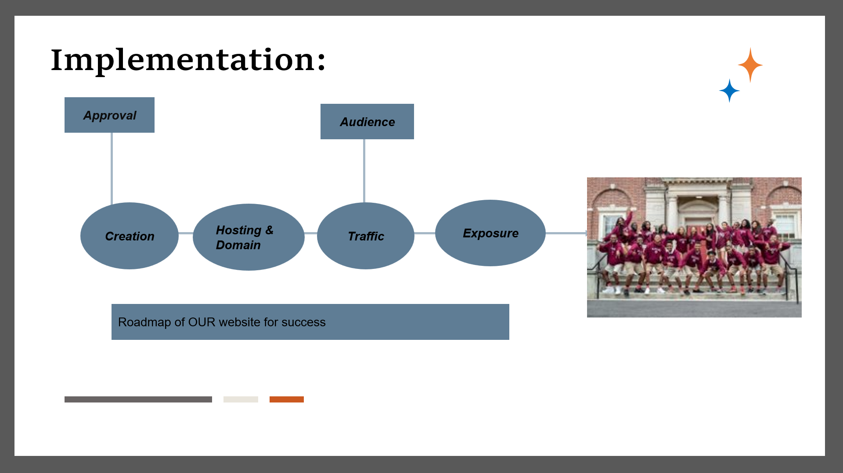

**4.3 Architecture**:

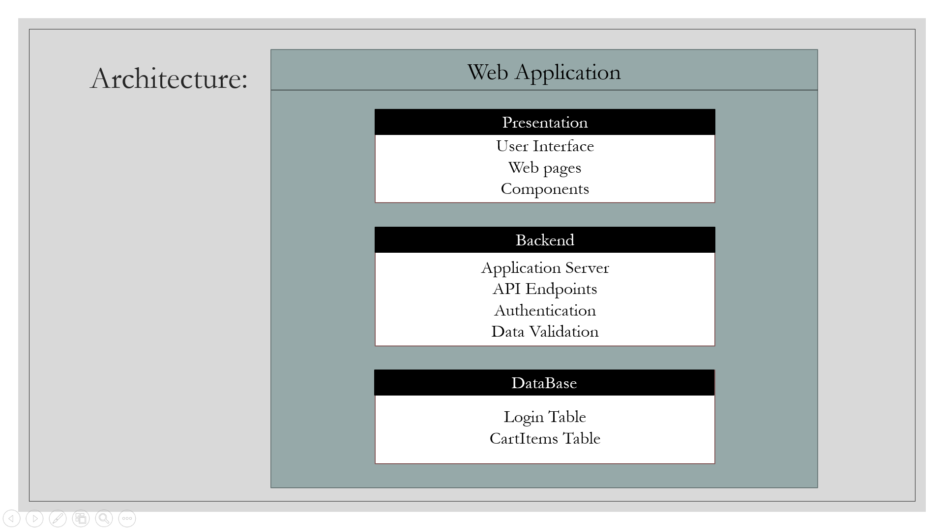

**CHAPTER – 5**

**CODE**

**5.1 Source Code**

**Home page code:**

<!doctype html>

<html lang="en">

<head>

<meta charset="utf-8">

<title>MRUClothing</title>

<base href="/">

<meta name="viewport" content="width=device-width, initial-scale=1">

<link rel="icon" type="image/x-icon" href="favicon.ico">

</head>

<body>

<header>

<nav class="navbar navbar-expand-lg navbar-light fixed-top p-0 ">

<div class="container-fluid m-1 justify-content-center">

<a >

<img src="../assets/picture/whitelogo-removebg-preview.png" alt="Logo" width="150" height="100">

</a>

</div>

</nav>

<nav class="navbar navbar-expand-lg navbar-light fixed-top p-0 " style="margin-top: 100px;height: 30px;" >

<div class="container-fluid">

<div class="collapse navbar-collapse justify-content-center" id="navbarNav">

<ul class="navbar-nav m-2">

<li class="nav-item ">

<a class="nav-link m-3" routerLink="/home"><h4>Home</h4></a>

</li>

<li class="nav-item">

<a class="nav-link m-3" routerLink="/products"><h4>Products</h4></a>

</li>

<li class="nav-item">

<a class="nav-link m-3" routerLink="/cart"><h4>cart</h4></a>

</li>

<li class="nav-item">

<a class="nav-link m-3" routerLink="/info"><h4>info</h4></a>

</li>

</ul>

</div>

</div>

</nav>

</header>

<main style="margin-top: 130px;">

<router-outlet></router-outlet>

</main>

<footer class=" text-center py-3 mt-5 text-white" style="background-color: #24308D;">

<div class="container-fluid p-4 ">

<div class="row mt-4">

<div class="col-lg-6 col-md-6 mb-4 mb-md-0">

<img src="../assets/picture/logofooter.jpeg" padding-top="2px" height="100px" width="200px">

<h1>MALLA REDDY UNIVERSITY</h1>

<p>

​(As per Telangana State Private Universities Act No.13 of 2020 and G.O.Ms.No.14, Higher Education (UE) Department)

</p></di

<div class="col-lg-6 col-md-6 mb-4 mb-md-0">

<h2>SOCIALIZE WITH US</h2>

<a type="button" class="btn btn-floating btn-transparent btn-lg" href="https://www.facebook.com/MallaReddyUniversity/"><img src="../assets/picture/fb.webp"></a>

<a type="button" class="btn btn-floating btn-transparent btn-lg" href="https://www.instagram.com/mallareddyuniversity/?hl=en"><img src="../assets/picture/in.webp"></a>

<a type="button" class="btn btn-floating btn-transparent btn-lg" href="https://www.youtube.com/channel/UCQ3p6CZhNku1Uwbn5r505zg"><img src="../assets/picture/yt.webp"></a>

<a type="button" class="btn btn-floating btn-transparent btn-lg" href="https://twitter.com/mallauniversity?lang=en"><img src="../assets/picture/t.webp"></a> </div>

</div>

</div>

<div class="text-center p-3" style="background-color: rgba(0, 0, 0, 0.2);">

© 2020 Copyright:

<a class="text-white" href="https://www.mallareddyuniversity.ac.in/">mallareddyunivsity.com</a>

</div>

</footer>

</body>

</html>

Product-list page:

<body>

<nav class="navbar navbar-expand-lg navbar-dark fixed-top" style="margin-top: 130px;" >

<div class="container-fluid">

<button class="navbar-toggler" type="button" data-bs-toggle="collapse" data-bs-target="#secondaryNavbar" aria-controls="secondaryNavbar" aria-expanded="false" aria-label="Toggle navigation">

<span class="navbar-toggler-icon"></span>

</button>

<div class="collapse navbar-collapse justify-content-center" id="secondaryNavbar" style="height: 20px;">

<ul class="navbar-nav">

<li class="nav-item">

<a class="nav-link" routerLink="/men">Men</a>

</li>

<li class="nav-item">

<a class="nav-link" routerLink="/women">Women</a>

</li>

<li class="nav-item">

<a class="nav-link" routerLink="/trending">Trending</a>

</li>

<li class="nav-item">

<a class="nav-link" routerLink="/accessories">Accessories</a>

</li>

</ul>

</div>

</div>

</nav>

<section>

<div class="container mt-4">

<div class="row">

<div *ngFor="let product of producttrending" class="col-md-4">

<div class="card mb-4 p-2 text-center">

<img [src]="product.imageUrl" alt="Product Image" class="card-img-top" height="400" >

<div class="card-body">

<h3 class="card-title">{{ product.name }}</h3>

<p class="card-text">Rs.{{ product.price}}</p>

<div class="btn-group" role="group">

<button type="button" class="btn btn-outline-primary"

[class.active]="product.selectedSize === 'S'"

(click)="product.selectedSize = 'S'">S</button>

<button type="button" class="btn btn-outline-primary"

[class.active]="product.selectedSize === 'M'"

(click)="product.selectedSize = 'M'">M</button>

<button type="button" class="btn btn-outline-primary"

[class.active]="product.selectedSize === 'L'"

(click)="product.selectedSize = 'L'">L</button>

</div>

</div>

<button (click)="addToCart(product)" class="btn btn-primary mt-2 p-2 text-center" id="atc"><h5>Add to Cart</h5></button>

</div>

</div>

</div>

</div>

</section>

</body>

Login page code:

<div class="container d-flex justify-content-center align-items-center">

<div class="w-50">

<h2>Login</h2>

<form>

<div class="mb-3">

<label for="name" class="form-label">Name</label>

<input type="text" class="form-control" id="name" [(ngModel)]="name" name="name">

</div>

<div class="mb-3">

<label for="email" class="form-label">Email</label>

<input type="email" class="form-control" id="email" [(ngModel)]="email" name="email">

</div>

<div class="mb-3">

<label for="password" class="form-label">Password</label>

<input type="password" class="form-control" id="password" [(ngModel)]="password" name="password">

</div>

<button class="btn btn-primary" (click)="onSubmit(email, password, name)">Login</button>

</form>

</div>

</div>

**Server.js code:**

const express = require('express');

const bodyParser = require('body-parser');

const cors = require('cors');

const mysql = require('mysql');

const app = express();

app.use(bodyParser.json());

app.use(cors());

app.use(express.json());

// Configure MySQL connection

const db = mysql.createConnection({

host: 'localhost',

user: 'root',

password: 'mysql',

database: 'mru_clothing',

});

// Connect to MySQL

db.connect((err) => {

if (err) {

throw err;

}

console.log('Connected to MySQL database');

});

// Create API endpoint to handle user login data insertion

app.post('/login', (req, res) => {

const {email, password,name } = req.body;

const query = `INSERT INTO login (email, password,name) VALUES ('${email}', '${password}','${name}')`;

db.query(query, (err, result) => {

if (err) {

console.error('Error inserting login data:', err);

res.status(500).json({ success: false, message: 'Error inserting login data' });

} else {

console.log('Login data inserted successfully');

res.status(200).json({ success: true, message: 'Login data inserted successfully' });

}

});

});

// API endpoint to add cart item

app.post('/cart/add', (req, res) => {

const { name, price, imageUrl } = req.body.product;

const query = `INSERT INTO cartitems (name, price, image_url) VALUES (?, ?, ?)`;

const values = [name, price, imageUrl];

db.query(query, values, (err, result) => {

if (err) {

console.error('Error inserting cart item:', err);

res.status(500).json({ success: false, message: 'Error inserting cart item' });

} else {

console.log('Cart item inserted successfully');

res.status(200).json({ success: true, message: 'Cart item inserted successfully' });

}

});

});

// API endpoint to remove cart item

app.post('/cart/remove', (req, res) => {

const { name } = req.body.item;

const query = `DELETE FROM cartitems WHERE name = ?`;

const values = [name];

db.query(query, values, (err, result) => {

if (err) {

console.error('Error removing cart item:', err);

res.status(500).json({ success: false, message: 'Error removing cart item' });

} else {

console.log('Cart item removed successfully');

res.status(200).json({ success: true, message: 'Cart item removed successfully' });

}

});

});

app.get('/', (req, res) => {

res.send('Welcome to the University Clothing website');

});

// Start the server

const port = 3000;

app.listen(port, () => {

console.log(`Server is running on port ${port}`);

});

**5.2 Screenshots of Application**

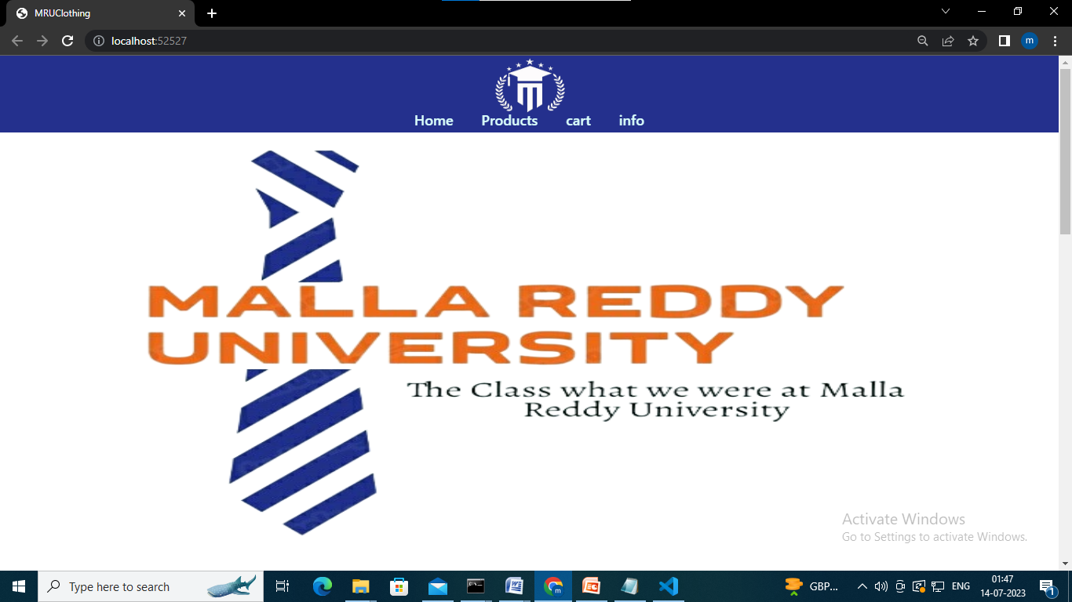

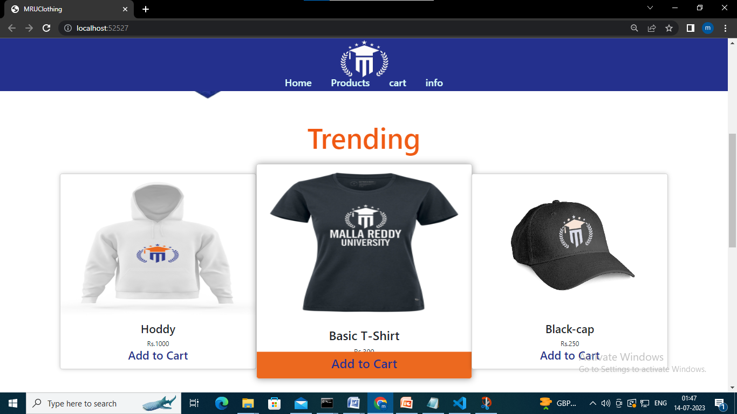

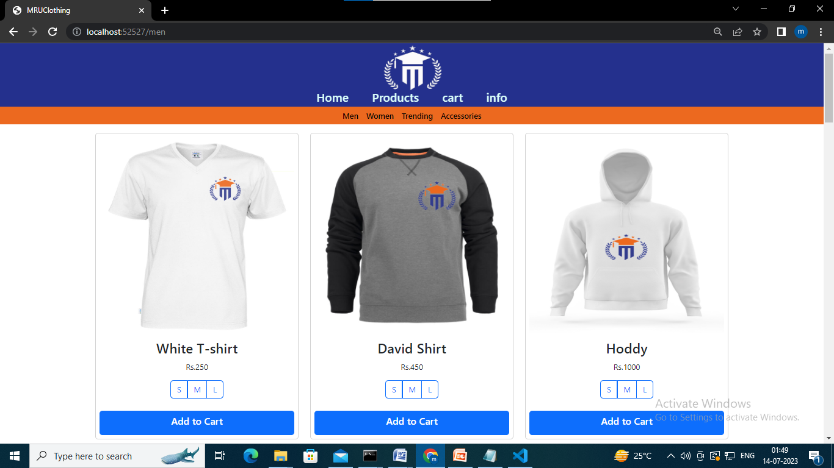

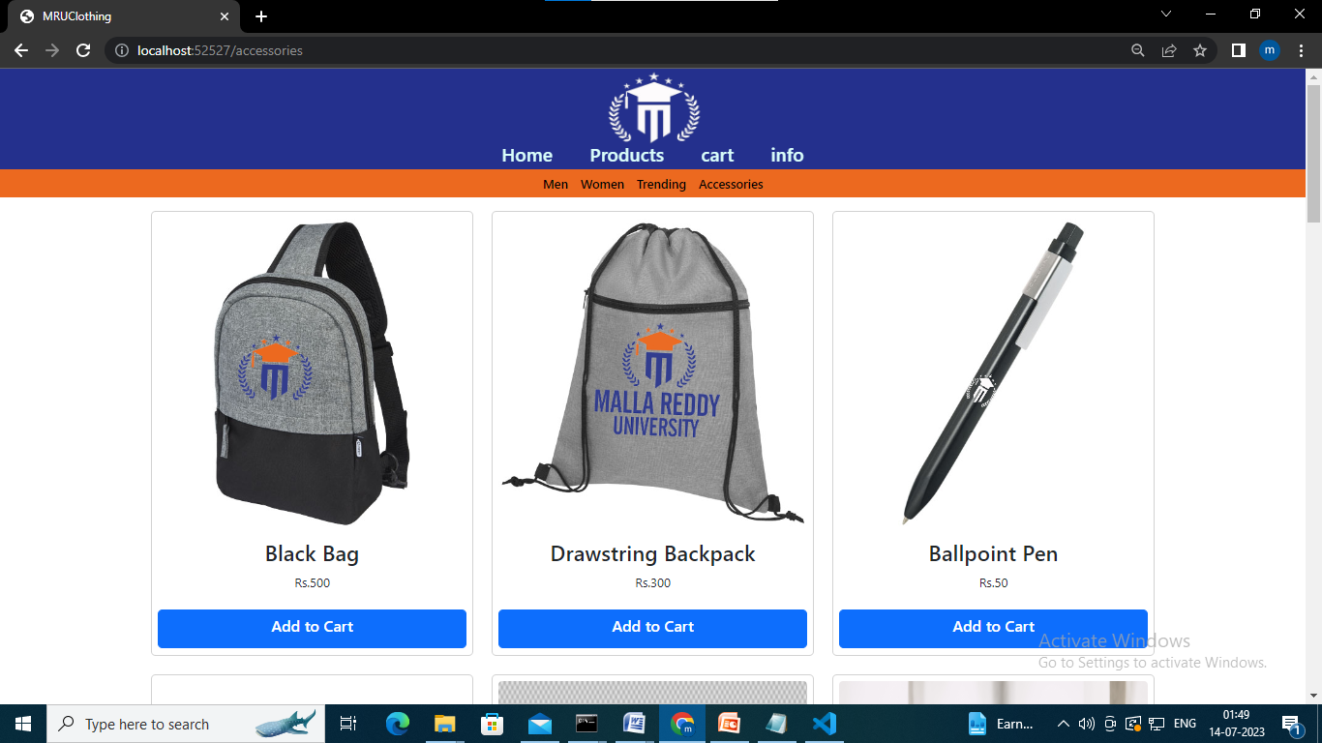

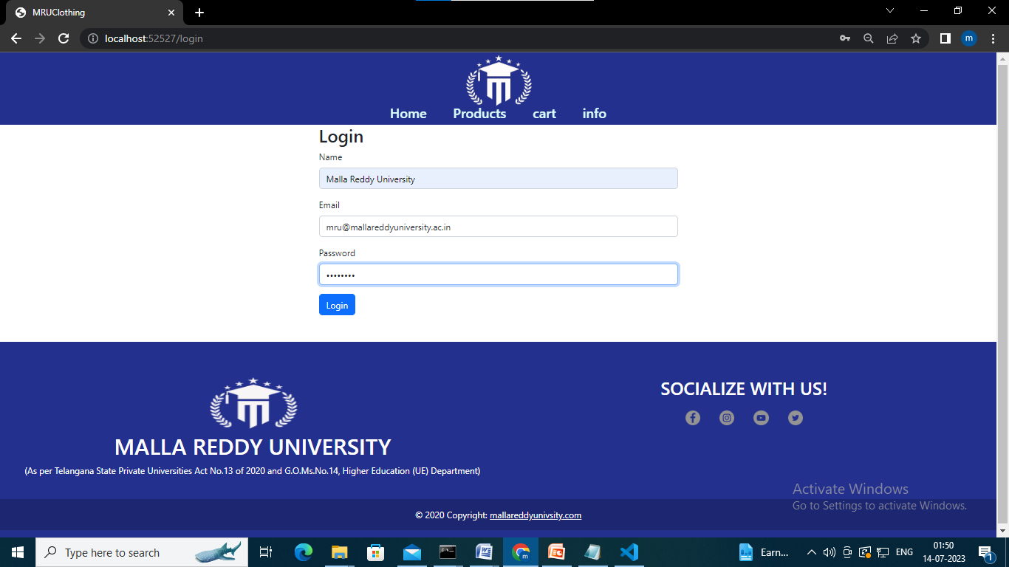

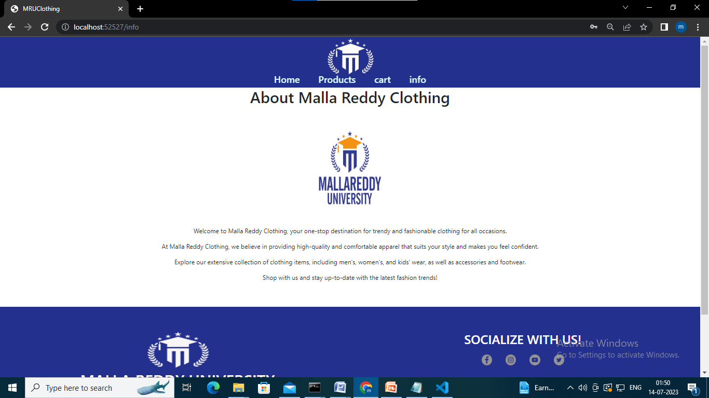

**CHAPTER – 6**

**RESULTS & CONCLUSION**

**6.1 Conclusion**

The Mallareddy University clothing report holds significant importance for various reasons. Firstly, it provides valuable insights into the clothing preferences and trends among the students and faculty of the university. This information can be used by the university administration to make informed decisions regarding the provision of appropriate clothing facilities on campus, such as establishing a university merchandise store or offering customized apparel options.

Secondly, the report can assist local businesses and clothing retailers in understanding the market demands and preferences of the university community. This knowledge can help them tailor their product offerings and marketing strategies to better cater to the needs of the students and faculty, ultimately leading to increased sales and customer satisfaction.

Additionally, the report can serve as a reference for future research and studies related to clothing preferences in educational institutions. It can contribute to a broader understanding of fashion trends and consumer behavior among university populations, aiding researchers and academicians in their studies.

Overall, the Mallareddy University clothing report plays a crucial role in providing valuable data, facilitating decision-making processes, supporting local businesses, and contributing to the existing body of knowledge in the field of clothing preferences in educational settings.

**REFERENCES:**

Articles and research papers related to e-commerce, website development, user experience, and online shopping.

Examples: "The Impact of Visual Design on User Perception in E-commerce Websites," "Responsive Web Design for Multi-Device User Experience," etc.

Include references to online resources, tutorials, and guides that have helped you in the development process or provided valuable insights.

Examples: Developer documentation, tutorials from platforms like Angular or Bootstrap, coding blogs, ChatGPT etc.